h

Functional Specification Document

Provast Service Portal Web Application

Document Control

Document Title | Functional Specification Document for Provast Service Portal Web Application
Purpose | To develop Provast Service Portal Web Application
File Name | FSD-Provast Service Portal Web Application _V1.0
File type | Microsoft Word
Prepared by | Ratnesh Kumar / Shivam Bhanot
Reviewed by | Dilip Sadh Sir
Checked by | Dilip Sadh Sir

TABLE OF CONTENTS

1. Purpose 3
2. Provast Service Portal Web Application work Flow Diagram 4
3. Client users Work flow 5
4. Facility Coordinator Users Flow chart of Working 5
5. Support Manager User Flow Chart 6
6. PSP Web Application Screens 7
7. User Login Page 9
8. Dash Board in Welcome Window 10
10. User Account Setup 15
11. Reset Password 17
12. Change Password 18
13. User Authorization 19
14. User Alert Setup 20
15. Document Numbering 22
18. Site Setup 25
19. Add Request-Client 27
20. Request Update-Client 29
21. Request Status-Client 31
22. Work Order 33
23. Budget Setup 55
24. Excess Budget Approval 57
25. Budget Expense Report 59
26. Material Requisition 61
27. Material Transfer 64
29. Reports 71

Purpose
Provast Limited (Nigeria) is a service provider company which basically provides services and maintenance to the different clients from different fields. To manage all the issue and solution log as well as tracking of services to the client the company requires an Online Service Portal. Through this portal the different clients log their issues which is taken care by customer service team and facility coordinators from different sites. In this online service portal Provast also manages their different budgets for different clients which are managed cost code wise so that they can have the data of agreed amount verses actual expenses done at the sites. The Provast team also manages the setup of client’s location wise, sub-location wise, sub-sub location wise and assets wise.
The facility coordinators are the responsible users to arrange the items (If needed) by generating material requests from the store, to update the work order screen (Solution knowledge based) and coordination with customer service team with e-mail alerts.
The customer service manager and their team are responsible for updating and making changes in the work orders and assigning it to the different facility coordinators.
The customer service team are responsible for status update as per work in progress like open, close and pending in SAP against the work orders.
To manage all these process an Online Service Portal will be developed and integrated with SAP B1 database.

Provast Service Portal Web Application work Flow Diagram
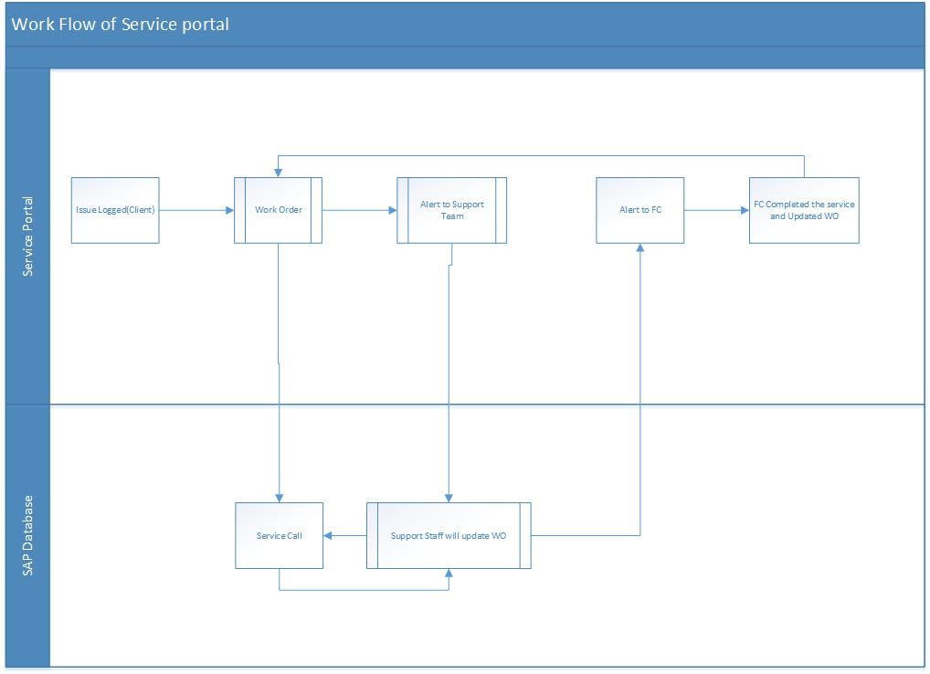

Client users Work flow
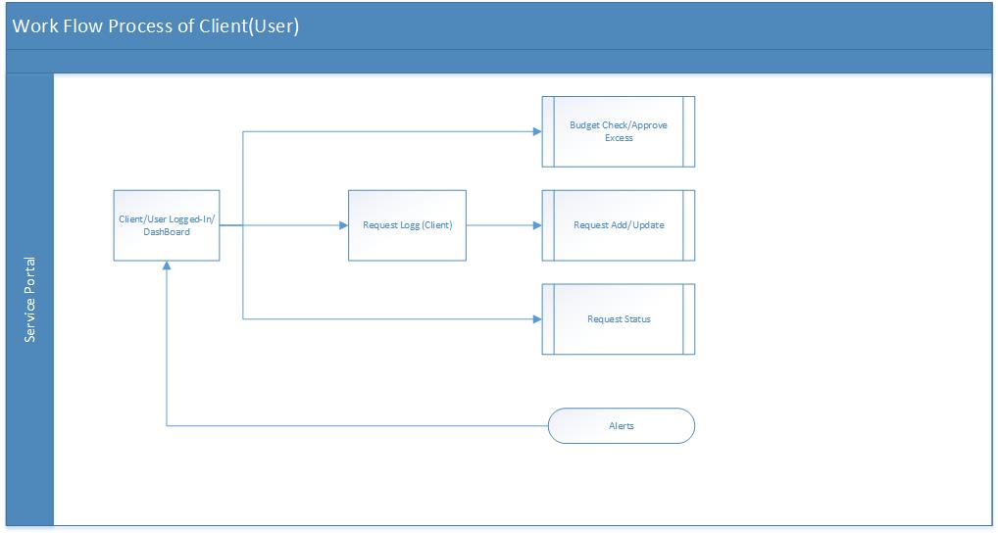

Facility Coordinator Users Flow chart of Working

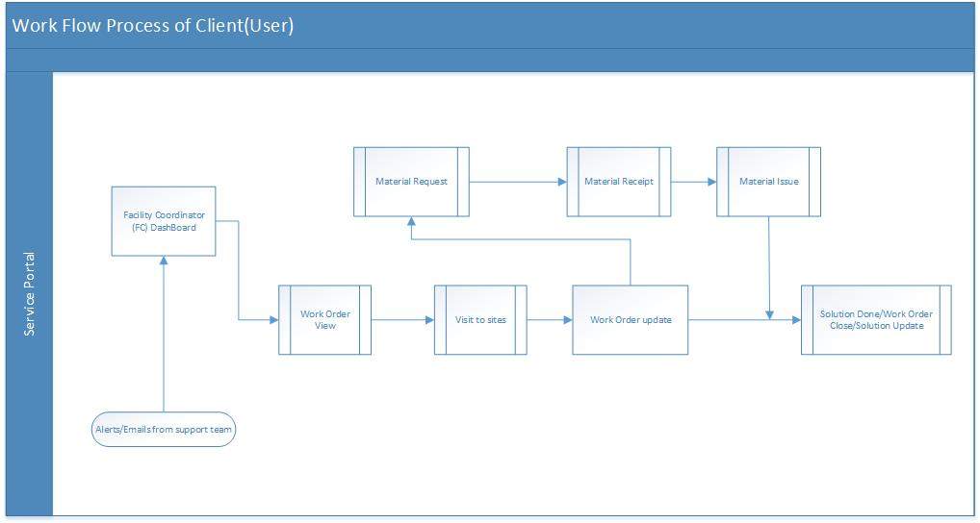

Support Manager User Flow Chart
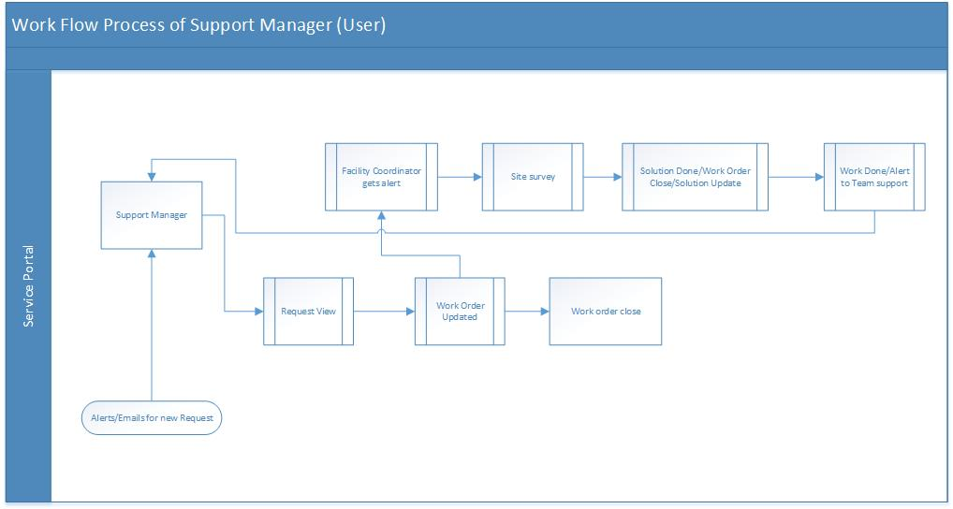

PSP Web Application Screens
Log-In Screen

Admin

Dashboard/Welcome screen
User Account Setup
User Authorization
User Alert setup
User Linking Setup
Site/User Linking Report
Data Import Utility
Reset Password
Change Password
Log-Out (Button)

Work Order

Site Setup
Add Request
Request Update
Request Status
Work order

Budget

Budget Setup
Excess Budget Approval
Budget Expenses Report

Inventory

Material Transfer Request
Material Transfer
Material Return

Reports

Work order Status Report (Open/Close/Canceled)
Work order client wise (Location /Sub location /Sub-Sub location/asset)
Work order Report (weekly/monthly/quarterly/yearly)
Monitor-Location wise/Filter (PPM/Including PPM/Excluding PPM)
Budget Client wise
Budget Location wise
Budget Asset wise

User Login Page

This screen will be used to login into PSP (Provast Service Portal) application by Super User/Support User/Client/Facility Coordinator.

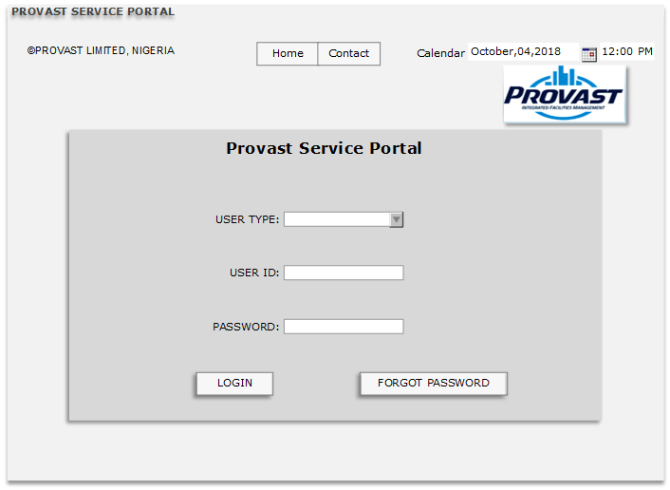

User Type | DDL will be there in which 4 types of User will come from table PSP User Type (Backend Fix Value) 1.Super User, 2.Client User, 3.FC User, 4. Support User  In DDL User type will come. Default value will be Select. Mandatory
User ID | Will be user id of user entered manually. Mandatory.(Unique, Alphanumeric Value)
Password | Will be password of user entered manually. Mandatory
Login | After successful validation system will login into the application and home page will be opened. On login system will check that For the selected User Type/User-user_id-password should match and all condition are true then system will allow to login.
Forget Password | If the user will click on forget password bottom then the registered email id will get a link of Change password, user will update there and again try to get logged in
Validations
 | If user id does not exist for the selected User type then system will show error message User Id does not exist for the selected User Type

Dash Board in Welcome Window
This is the Dash Board of the Service portal which consist of Static Reports.
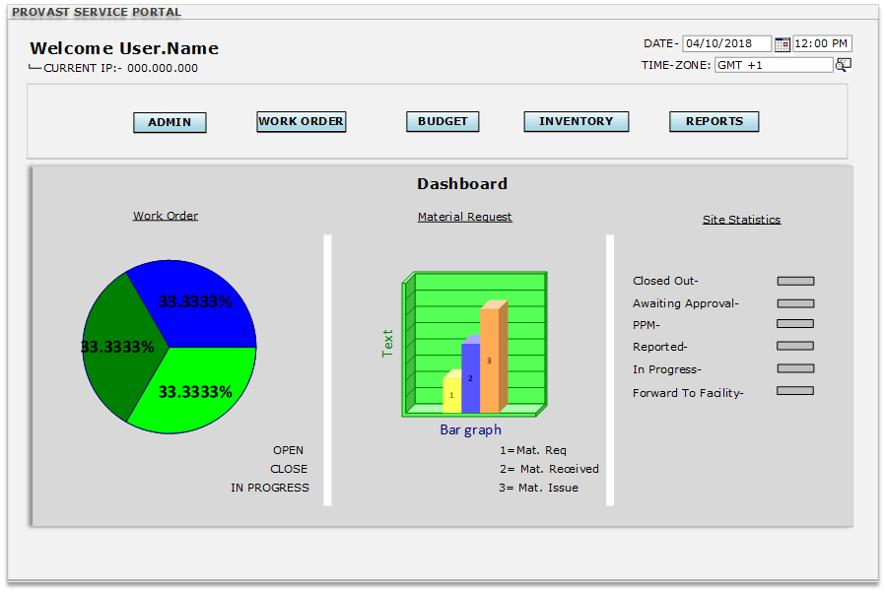

Welcome Screen/Dash Board | After doing Successful login in the PSP_web Application this window will appear to the users. This screen will show the name of the user, current IP, current date, current time and time zone. This is the view screen
Admin | This TAB consist of Dashborad,User Account setup, User authorization, User alert setup,doc.numbering,user linking setup, data export import Utility, reset password and Logout screens.
Work Order | This TAB consist of Site Setup, Add Request, Request Update, Request Status, Work order screens
Budget | This TAB consist of Budget Setup, Budget Update, Budget Expenses, Over Budget Approval SCREENS
Inventory | This TAB consist of Material Request, Material Transfer Receipt, Material Issue screens
Reports | This TAB consist of Work order Status Report (Open/Close/Canceled),Work order client wise (Location /Sub location /Sub-Sub location/asset),Work order Report (weekly/monthly/quarterly/yearly),Monitor-Location wise/Filter (PPM/Including PPM/Excluding PPM),Budget Client wise, Budget Location wise, Budget Asset wise screens
Work order Dash board | In this screen it will show all the work order(open/Close/In progress) in percentage  Open-The Work order which has not been yet assigned to technician  In progress-once the technician is updated in the work order then the status here in Dashboard will be considered as In progress and also for the clients while checking the Request status report.  Close- Close percentage Is that this work order has finished.
Material Transaction | In this screen it will show all the Material transaction in Graph form
Site Statistics | This will show the whole transaction stats according to recorded transaction

- Sub-menu Tabs
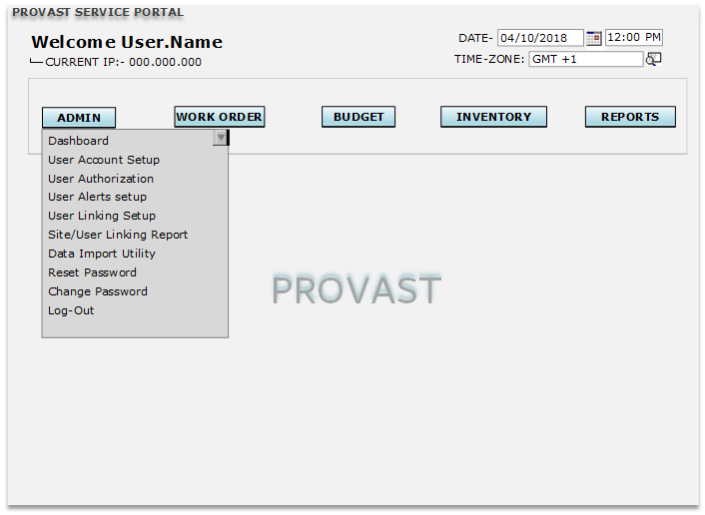
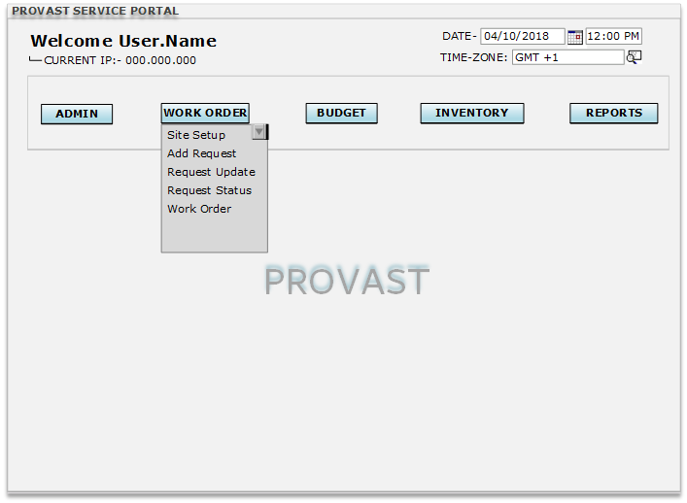
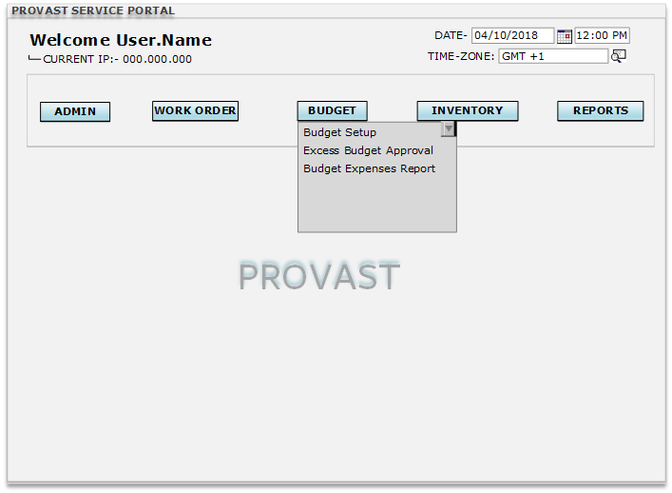
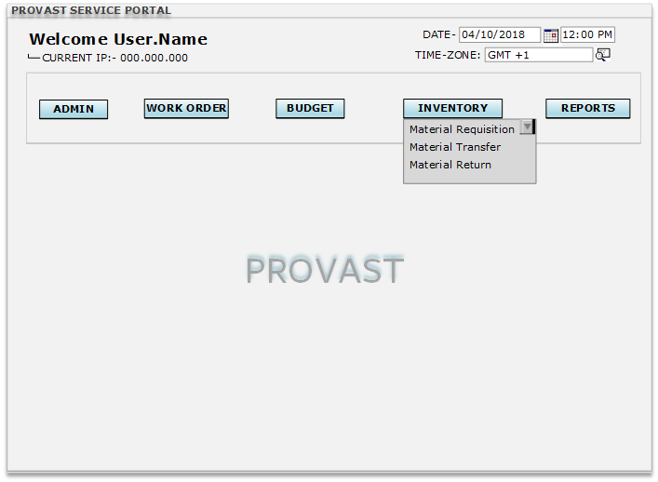
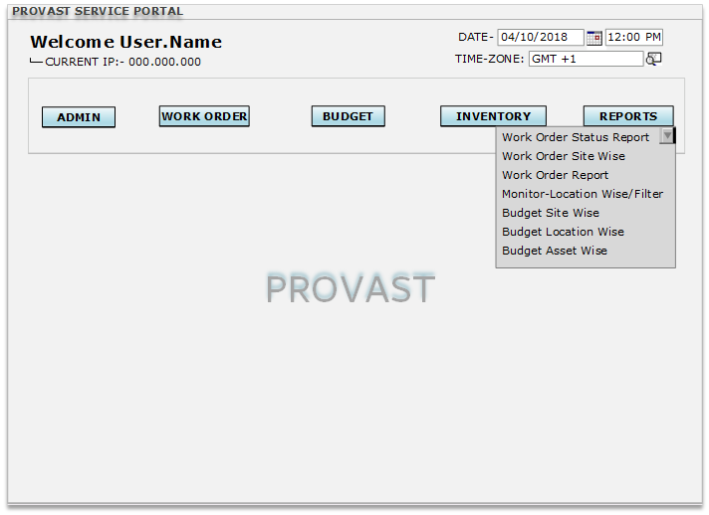

User Account Setup

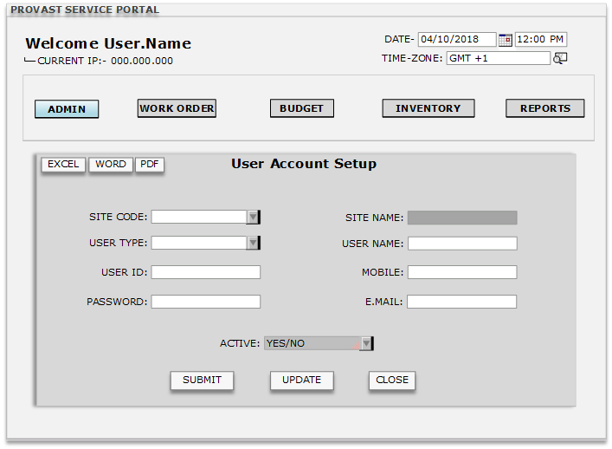

Site Code | DDL will be there in which data will come from SAP_BP Master Data (OCRD_BPCode).  In CFL Values will be site name/Site code, it will be searched by alphabets in column wise (only one can be selected).  From the DDL the user type will be selected, for a user only one type of user type will be selected.  (Note-Default Site will be Provast Ltd and other will come from SAP OCRD database. If we will create user by selecting in Provast ltd the user will be created in this site)
Site Name | This field will remain freezed and in this field data will come from SAP_BP Master Data (OCRD_BPName) automatically when Site code is selected.  (Note-Default Site will be Provast Ltd and other will come from SAP OCRD database. If we will create user by selecting in Provast ltd the user will be created in this site)
User Type | Drop down will be there for selecting the user type. Without selecting the user type this document will not added, if added without selecting then error message will come” please select any one of user type.  (Note –this type of User have full access to change ,update and add new,we can also set authorization on this type of user)
User Name | This field will be a free text field the user’s name will be defined in this field.
User ID | In this field user will enter data manually. (Alphanumeric,20) Mandatory. In user Id space and special characters will not be allowed.  (NOTE- user ID will be filtered according to the site and user type which we had defined in User Setup)
Password | There will be a field in the table named password. The password will be set by super user.
Mobile | This field will be a free numerical field which will allow the user to enter the contact details of the user whose account is being registered.  (NOTE- Will only contain numeric values)
Email | This field will be a free text field which will allow the user to enter the Email id of the user whose account is being registered.
Active | DDL will be there and values in DDL will be Yes and No and default value will be Yes.
Submit | On submit button data will be save first time, and if user change any details form will be in update mode. On user id creation message will be User Id created successfully.
Update | In update mode user can change user name, Email id and mobile no. and make inactive to the user, all other fields will be read only. On update message will be User Id details updated successfully.
Close | Clicking Cancel Button will close the window.  (NOTE- While clicking on cancel button system will ask user to save the document, for saving the document system will ask YES or NO.)
Validations
1 | User ID will be 8 digit Mandatory if not selected system will show error message Please enter user ID first more than 8 digit.
2 | Default password will be User ID + user type(Super user/FC user/Client user)

Reset Password
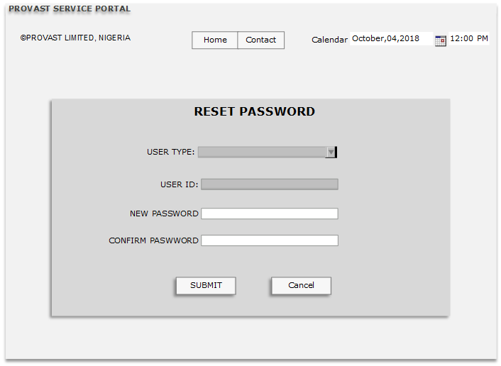

User type | After clicking the link the window will be open with Auto selected User type and User ID,
User ID | The user ID will be automatically appear and freezed
New Password | User will enter manually. Mandatory (minimum 8 digit)
Confirm Password | User will enter manually. Mandatory
Update | By pressing the update button the new password will be updated

Change Password
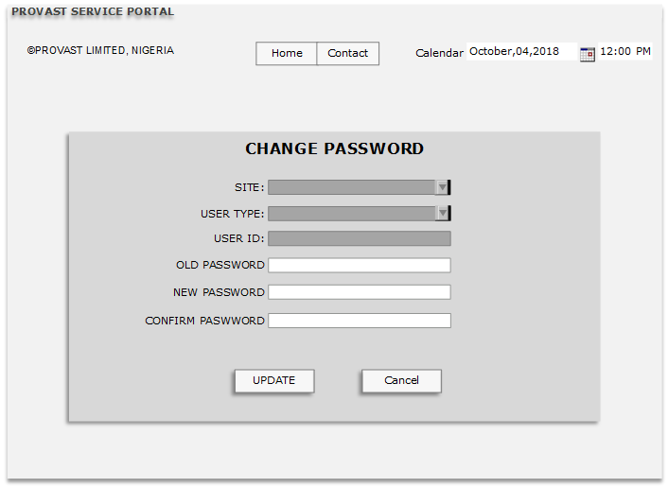

Site | This field will show the Site/client who has requested for a password change and data is coming from OCRD Sap database. This field will remain freezed.
User Type | User type will come automatically from the user’s detail who has requested for a password change. This field will remain freezed.
User Id | User ID will come automatically from the details of the user who has requested for a password change. This field will remain freezed.
Old Password | User will enter manually. Mandatory
New Password | User will enter manually. Mandatory
Confirm Password | User will enter manually. Mandatory
Update | If all validation are fulfil system will update the existing password of user id for the selected User type
Validation
1 | Old Password -If user enter wrong password then error message will be Password does not match.
2 | New password and confirm password should be same otherwise error message will be there New password and confirm password should be same

User Authorization
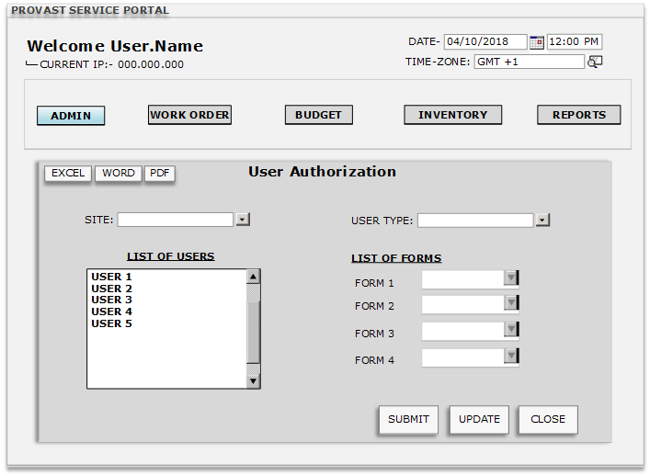

Site | This is for selection of Site/client, CFL will be there, and data will come from OCRD_BpName Sap database.
User Type | User Type is to be selected from the DDL .User type will come from the User type master
List Of Users | This window will show the user according to the selected site, The list will be only from the selected site as setup in the user account.  (NOTE- List of users will be filtered according to the site and user type as we have defined in the user setup.)
List of forms | This window will be freezed, once we click on user the list of form will be enable and user can select the option from the DDL(read only, Full authorization, No authorization)
Submit | This Button will submit the data as we have fixed user wise
Update | The update button will be enable if we will make any change in the List of user-DDL
Close | This close button will close the window of Authorization
Validations
1. | Only Super User type user can make changes in this form for other users this form will be disabled.

User Alert Setup
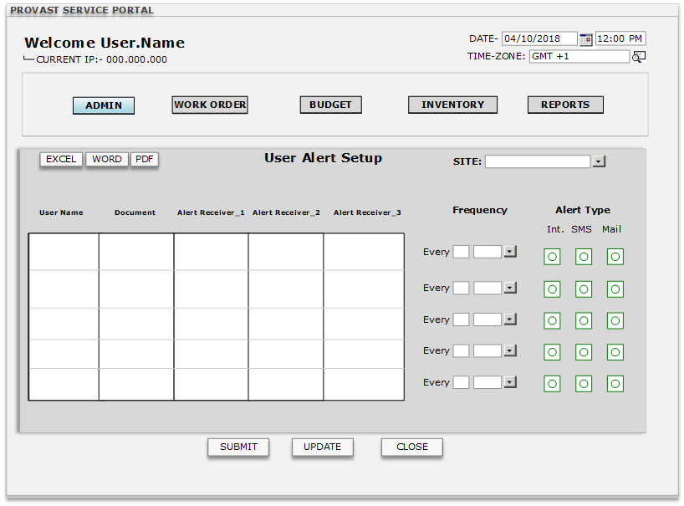

Site | This is for selection of Site/client, CFL will be there, and data will come from OCRD_BpName Sap database.
User Name | User name will be from the user Account setup window of the portal. Editable as well it will come from SAP database OHEM_EmpID  (NOTE- User name will be filtered according to the site and user type selection.)
Document | Here all the document will be in DDL, the user will select the document on which they have to authorize.
Alert receiver 1 | The User ID will be selected from User Master DDL for the alerts receiver.  (NOTE- This list will show all the user from the chosen site.)
Alert receiver 2 | The User ID will be selected from User Master DDL for the alerts receiver.  (NOTE- This list will show all the user from the chosen site.)
Alert receiver 3 | The User ID will be selected from User Master DDL for the alerts receiver.  (NOTE- This list will show all the user from the chosen site.)
Frequency | In frequency we will set the Time of reminder of the alerts
Alert type | In this we have to set the alert type like SMS, emails and Internal
Submit | Clicking this button it will submit all the details in the table
Update | If the user will change any of the data the Update button will be enabled
Close | Close Button will close the window and also ask the user for saving the data yes/No
Validation
1. | Site wise user will be filtered, multiple user can be selected for multiple forms.

Document Numbering
We are having few transaction screens in which there is Document number. That Document number will be same to the SAP Database screen.

- Service call Document Number=Work Order Document Number
- Inventory transfer Request Document Number=Material request Number
- Inventory transfer Document Number=Material Transfer number
- Inventory Transfer Document Number= Material return Number.
Validation-
- In backend the series will be running as per SAP B1 database.

- User-Linking Setup

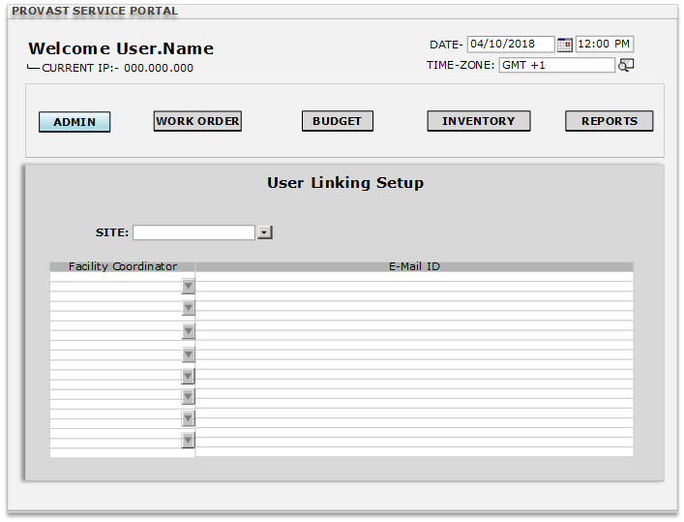
Site | This is for selection of Site/client, CFL will be there, and data will come from OCRD_BpName from SAP database.
Facility Coordinator | This field will contain a CFL which will show names of all the facility coordinators defined in OHEM_FirstName and OHEM_LastName in SAP B1 database.  (NOTE- The list open in CFL will contain employee ID (OHEM_EmpID, OHEM_FirstName, OHEM_Last Name, OHEM_Dept, OHEM_Position)
Email ID | This field will automatically pick the Email ID’s of the facility coordinator as defined in OHEM_Email in SAP B1 database.
 | Note-If the email ID is not updated then the Admin have to define the email ID in SAP database

- Site/User Linking Report

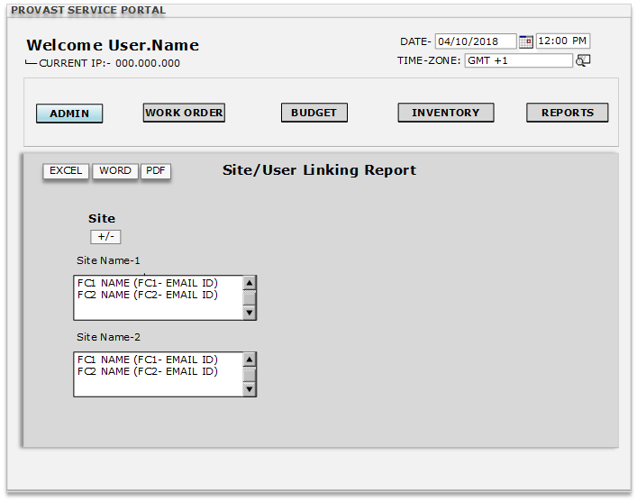
Site | This is for selection of Site/client, CFL will be there, and data will come from OCRD_BpName from SAP database.
Site +/- | After clicking on this all the list will be expanded and also collapse on next click.
Site 1/2 | This is the example of name of the site. The report will contain all the site with Facility coordinator name and their respective Email ID.

- Data Import Utility

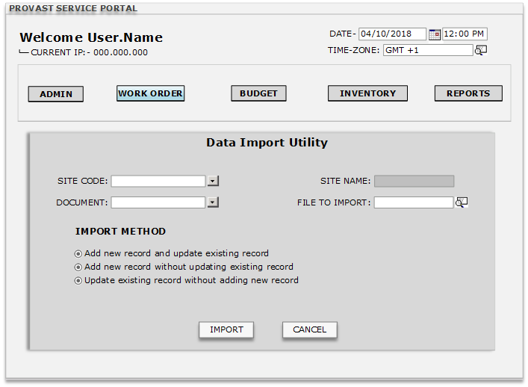
Site Code | This is for selection of Site/client, CFL will be there, and data will come from OCRD_BpCode Sap database.
Site Name | The name in this field will come automatically from the selected Site Code from OCRD_BpName SAP database. The field will remain freezed.
File To Import | This field will have a Choose file option which will help the user to select the Data file that has to be added or updated in the system.
Document | This field will have a drop down button listing all the documents present in the system.
Import Method | This field will contain three types of check-box option with values like-  (1. Add new record and update existing record)  (2. Add new record without updating existing record)  (3. Update existing record without adding new record)  By default no check-box will be selected.
Import | Clicking the Import Button will start the process of importing the Data file to the system’s database. The changes made through this window will also be updated in SAP B1 database.
Message Box (Error) | Error message will trigger if the data is not proper or not in proper format.  (NOTE- Template will/format will be provided by portal developers to upload data.)
Cancel | Clicking Cancel Button will close the window.

Site Setup
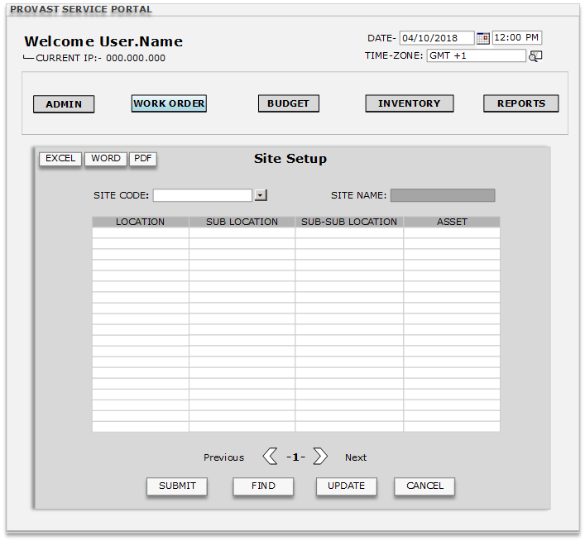

Site Code | This is for selection of Site/client, CFL will be there, and data will come from OCRD_BpCode from Sap database. Site will be only in editing mode when user type is client user.
Site Name | The name in this field will come automatically from the selected Site Code from OCRD_BpName SAP database. The field will remain freezed.
Location | Location field will be a free text field which will allow user to add location info of the site.
Sub Location | Sub Location field will be a free text field which will allow user to add sub location info of the site.
Sub-Sub Location | Sub-Sub Location field will be a free text field which will allow user to add sub-sub location info of the site.
Asset | Asset field will be a free text field which will allow user to add asset info of the site.
Navigation bar | Will help in navigating to different Sites with all details. (Previous/Next)
Submit | Clicking Submit Button will add the document in the portal.
Find | Clicking the find button will auto-freeze the window except Site code. In site code the user will be able to find by inserting * (It will open a new window with all the site with their site, location, sub-location, sub-sub location and asset.) or selecting the particular site.
Update | Clicking Update Button will update the document with updated data in the system.
Cancel | Clicking Cancel Button will close the window.  (NOTE- While clicking on cancel button system will ask user to save the document, for saving the document system will ask YES or NO.)
Validation
1. | This form will open with blank sheet, after selecting the site the form will show the related data of that site. If we will make any changes then Update button will enable and we can update that data.

Add Request-Client
This screen will be for the Client/Site type users, through this screen they will request the service. This screen will add the work order also in Portal and SAP Database. After logged in the client will only able to see their location and assets
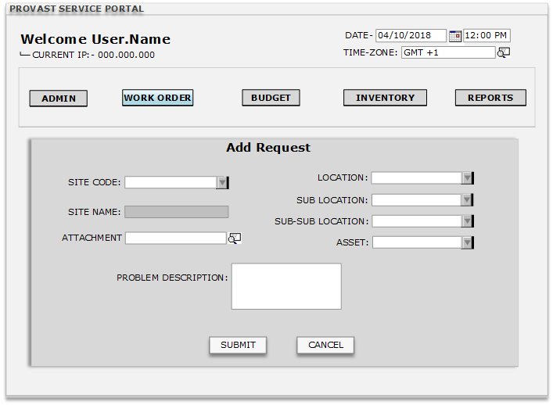
Site Code | This is for selection of Site/client, CFL will be there, and data will come from OCRD_BpCode from Sap database. Site will be only in editing mode when user type is client user.
Site Name | The name in this field will come automatically from the selected Site Code from OCRD_BpName SAP database. The field will remain freezed.
Location | Location will come from the site setup screen where the location has been linked for the different sites and this location will also update in SAP database.(OSCL.U_LOC)
Sub Location | Sub-Location will come from the site setup screen where the Sub-Location has been linked for the different sites/Locations and this will also update in SAP database (OSCL.U_SLOC)
Sub-Sub Location | Sub-Sub-Location will come from the site setup screen where the Sub-Sub-Location has been linked for the different sites/Locations/Sub locations and this will also update in SAP database (OSCL.U_SSLOC)
Asset | Assets will come from the site setup screen where the Assets has been Linked for the different sites/Locations/Sub locations/Sub-Sub location and this will also update in SAP database (OSCL.U_ASSET)
Attachment | If there is any Picture/Snap/PDF etc. are there then user will be able to attach that(In portal) and this will also update in SAP database (ATC1_File Name)
Problem Description | In this screen the user will input there issue/problem they are facing. This will also update in SAP database (OSCL.Subject)
Submit | By clicking Submit button data will be saved in the table of Portal and New service call will be added in SAP Database (OSCL) with document number automatically generated in SAP.  (NOTE- Alert and email will trigger while adding a new Call/work order in SAP to the Support team and 1 email will trigger with work order number to the client also with info (Your work order has been generated, work order number is ######)
Cancel | Cancel is the button which will close the screen and also on clicking this system will ask to save Yes/no
Validation
1 | After logging, client will be able to see their data only like,Location,sub location asset etc.
2 | Sub Location, Sub-Sub Location are not mandatory selections.
3 | After adding the request a Ticket is generated in the form of Email and internal message  (Message- work order have been generated for (site name) (work order no.) (Subject) )

Request Update-Client
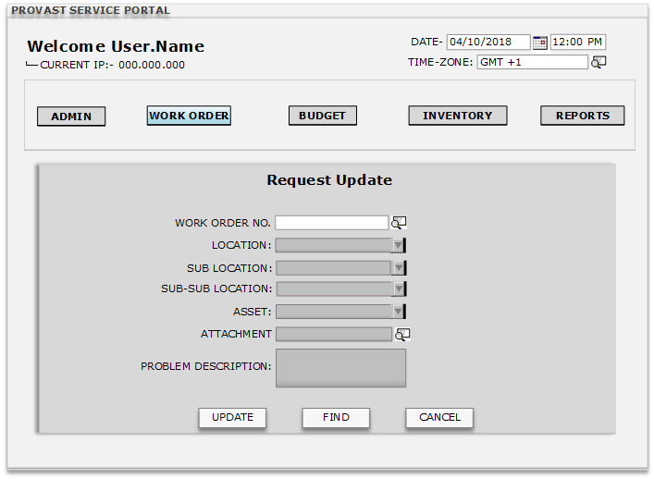
Work order no. | The user will input the work order number here, or the user can select from the list of open work order.  (NOTE- Work order number is generated automatically in SAP database (OSCL_DocNum) will be generating a new document in portal also with same document number.)
Location | Location field will be automatically appear while selecting the work order number which user had defined earlier at the add request level. This will be in edit mode
Sub location | Sub Location field will be automatically appear while selecting the work order number which user had defined earlier at the add request level. This will be in edit mode
Sub-Sub location | Sub-Sub Location field will be automatically appear while selecting the work order number which user had defined earlier at the add request level. This will be in edit mode
Asset | Asset field will be automatically appear while selecting the work order number which user had defined earlier at the add request level. This will be in edit mode
Attachments | The attachment they had screen will also visible and will be showing the attached file. This will be in edit mode
Problem descriptions | The problem description field will be appearing with the data user has saved earlier. This will be in edit mode
Update | Clicking Update Button will update the document with updated data in the system.
Find | In find mode only work order number will be enabled other fields will be disabled.
Cancel | Clicking Cancel Button will close the window.  (NOTE- While clicking on cancel button system will ask user to save the document, for saving the document system will ask YES or NO.)
Validation
1 | This screen will be open in find mode always
2 | It will be updated till the time, support manager has not assigned the technician/Facility coordinator for that service call/work order.

Request Status-Client
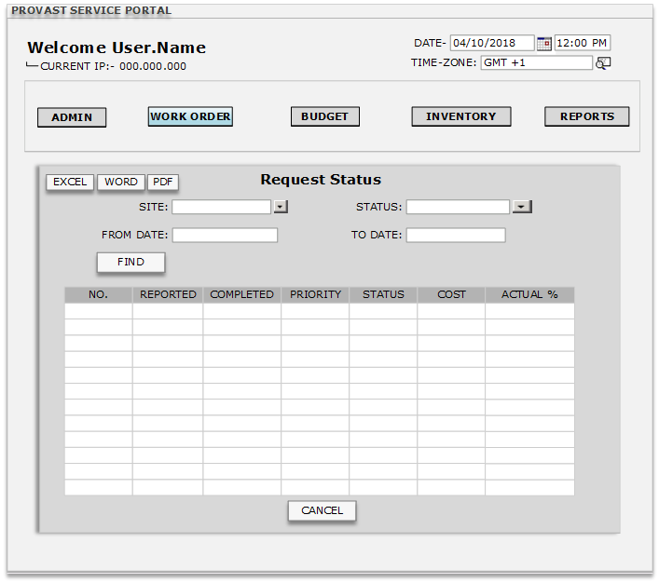

Site | This site name will automatically come from client type user (The site selected while logging in portal will be here automatically.)  (NOTE- Site will be only in editing mode when user type is Super user.)
Status | This field will contain a drop-down button which will have options like Open and Closed From SAP Database OSCL_Status
From Date | This field will have calendar option that will allow the user to select a date that will specify the beginning period of the status report From SAP database OSCL_CreateDate
To Date | This field will have calendar option that will allow the user to select a date that will specify the ending period of the status report From SAP database OSCL_
No. | This field will contain the list of all Work Orders which are requested in the specified period in the document for the particular site.
Reported | This field will contain the date of work order being reported to the service provider. The date will come from work order document generated for the particular site. (OSCL_StartDate)
Completed | This field will contain the date when the work order being is complete. The date will come from work order document generated for a particular site. (OSCL_EndDate)
Priority | This field will contain the priority status of the work order. This will come from work order document generated for the particular site. (OSCL_Priority)
Status | This field will contain info about the status of the work order. This will come from work order document generated for the particular site.(OSCL_Status)
Cost | This cost field will update automatically from OSCL_U_SOSC.
Actual % | This actual % will be calculated according to the duration (OSCL_U_ACT)  Note – different Status will be defined by % value.
Find | Clicking find button will show the report according to the parameter given (From date/ To date)
Cancel | Clicking Cancel Button will close the window.

This is the work order screen which is totally synchronizing with the service call screen of SAP Database. This screen are used by the clients for adding the request, for Support team to forward the request and for FC to update the Resolution.

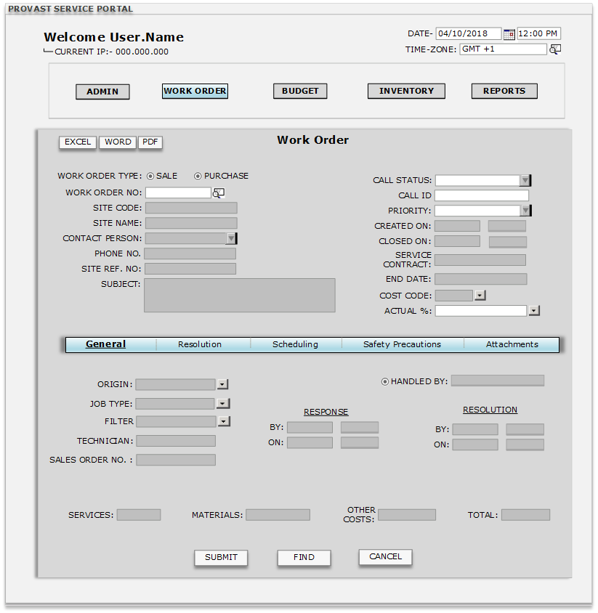
Work Order Type | This field will contain two options (Sale/Purchase) OSCL_BPType, which will be in the form of check box. The data entered in this field will be updated in SAP B1 database too. By default the (Sale) check box will be selected.  List will be filtered on the Basis of Work order type(If Check on Purchase then vendor list will be open and if sales is checked then Customer list will be open) here for purchase Cardtype is P and for sale Cardtype is C
Work Order No. | This field will contain a W/O number which will be generated automatically according to the document numbering defined and this number will also update in SAP B1 database OSCL_DocNum screen.
Site Code | This field will contain the site code which will come from the W/O request added by the client on the portal. The data will also be updated on SAP B1 database (OSCL_CardCode) against the service call.
Site Name | This field will contain the info of site name which will come from the W/O request added by the client on the portal. The data will also be updated on SAP B1 database (OSCL_CardName).
Contact Person | This field will contain the name of the contact person linked with the particular site (linked in SAP B1 database) which is selected in the W/O request document. If no contact person is linked the field will be left blank. OSCL_ContactCode (coming with Customer/Supplier selection)
Phone No. | This field will contain the phone number linked with the particular site (linked in SAP B1 database) which is selected in the W/O request document. If no contact person is linked the field will be left blank. OSCL_Telephone (coming with Customer/Supplier selection Master table OCRD)
Site Ref No. | This field will contain the Site Reference Number linked with the particular site (linked in SAP B1 database) which is selected in the W/O request document. If no contact person is linked the field will be left blank. OSCL_NumAtCard (coming with Customer/Supplier selection Master table OCRD)
Subject | This field will contain the subject text which will come automatically from the W/O request document created by the client. This field will remain open for further updates. Any update done will also be updated in SAP B1 database. OSCL_Subject (It is manually entered)
Call Status | This field will contain a drop down button with values like (Open/Closed/Pending) and will have an option of adding new value. The entries or changes done in this field will also be updated in SAP B1 database. OSCL_Status (By default status will be OPEN)
Call ID | This field will contain a Call ID number which will be similar to the number series present in the SAP B1 database. OSCL_callID (Will be automatically increasing number series)
Priority | This field will contain a drop down button with values like (Low/Medium/High) The entries done in this field will also be updated in SAP B1 database. OSCL_priority (By default will be LOW)
Created On | This field will contain the date and time when the W/O request is added by the client. This field will remain freezed and data will be updated in SAP B1 database also. OSCL_createDate, OSCL_createTime (Will automatically pick from system’s date and time)
Closed On | This field will have the info of Date and Time when the W/O request is closed by the Super User. The data in field will be updated in SAP B1 database also. This field will remain freezed. OSCL_closeDate, OSCL_closeTime (Will automatically pick from system’s date and time)
Service Contract | This field will have the Service Contract Number which will come from the linked contact for a site in the SAP B1 database. This field will remain freezed. OSCL_contractID (Will come from the contract defined in item master data OITM)
End Date | This field will have the Service contract end date which will come from the linked contact for a site in the SAP B1 database. This field will remain freezed. OSCL_cntrctDate (The date will come from data specified in the service contract in OITM item master)
Cost Code | Cost Code field will contain a CFL button which will display the list of all Cost/Account codes for selection purpose, this will come from SAP Database. OOCR_OcrName.
Actual % | This field will contain a drop down button support user and facility coordinator will update according to their work in progress. Will come from (OSCL_U_ACT) SAP B1 database.
Origin | This field will have a Drop-Down button with values like  (E-Mail, Phone, Web) and will allow super user to add new values to the drop-down. The entries done in this field will also be updated in SAP B1 database. OSCL_origin (By default will be blank)
Job Type | This field will have a Drop-Down button with values like (Admin, Air conditioning, Aluminum, Carpentry, Civil, Cleaning, Drivers, Electrical, Mason, Mechanical, Painting, Plumbing, Request, Supervisor, Welding, Repair etc.). The value in the field will be fixed. The entries done in this field will also be updated in SAP B1 database. OSCL_problemTyp (Will be blank by default and will contain an Add New option)
Filter | This field will have a Drop-Down button with values like (PPM, PPM Included and PPM Excluded). The value in the field will be fixed. The entries done in this field will also be updated in SAP B1 database. OSCL_ProSubType (Will be blank be default and will contain an Add New option)
Technician | This field will contain a CFL button which will open the list of technicians defined in the SAP B1. The entries done in this field will also be updated in SAP B1 database. OHEM_firstName (Will come from employee master data)
Sales Order No. | This field will contain the S/O Number of the Sales order document which will automatically come when the Work order is selected. The filed will remain freezed. OSCL,U_SONum (Will be updated once sales order will be created against this W/O or service call)
Handled By | This field will have the name of the Super user who has logged into the system. The name will come automatically and the filed will have a drop down box mentioning the name of other users defined on SAP B1 database. The entries done in this field will also be updated in SAP B1 database. OSCL_isQueue, OSCL_assignee (Will be the name of the user who has logged in)
Response | This field will remain freezed and show the info from the Response tab automatically. OSCL_respByDate, OSCL_respByTime, OSCL_respOndate, OSCL_respOnTime (The data will come from scheduling tab present in the window)
Resolution | This field will remain freezed and show the info from the Resolution tab automatically. OSCL_resolDate, OSCL_resolTime, OSCL_resolOnDate, OSCL_resolOnTime (The data will come from Resolution tab in the window)
Service | The value in this field will come automatically from the selected Sales Order document and will be freezed. (This field will only retrieve value of the items belonging to the Service Type group (OITB_ItemsGrpName). Calculation= Sum of line total of item belongs to service group) RDR1_LineTotal, Where OITB_ItemsGrpName=Service
Material | The value in this field will come automatically from the selected Sales Order document and will be freezed. (This field will only retrieve value of all the Item group except item group service. (OITB_ItemsGrpName). Calculation= Sum of line total of all item except service item group) RDR1_LineTotal
Other Costs | The value in this field will come automatically from the selected Sales Order document and will be freezed. The value will come from the sum of selected freights RDR3_Freight.
Total | The value in this field will come automatically from the updated Sales Order document and this field will be freezed. The value will come from the doc total amount of the S/O document. ORDR_DocTotal to this work order screen in the field OSCL_U_SOSC.  (NOTE- The sales order number which will be updated in Work order, this total will come from that sales order.)
Submit | Clicking Submit Button will add the document in the system. (OSCL)
Find | Clicking the find button will auto-freeze the window except Site code. In site code the user will be able to find by inserting * (It will open a new window with all the site with their site, location, sub-location, sub-sub location and asset.) or selecting the particular site.
Cancel | Clicking Cancel Button will close the window.  (NOTE- While clicking on cancel button system will ask user to save the document, for saving the document system will ask YES or NO.)
Validation
1 | In work order type if Sale type will be selected the customer master will only come and if Purchase type will be selected Supplier list will only come
2 | In sales order screen work order number selection is mandatory so that on work order screen the sales order number and sales order doc total will update automatically.
3. | This screen will open in find mode so that user will input the work order no. and he/she will be able to see specific work order screen.

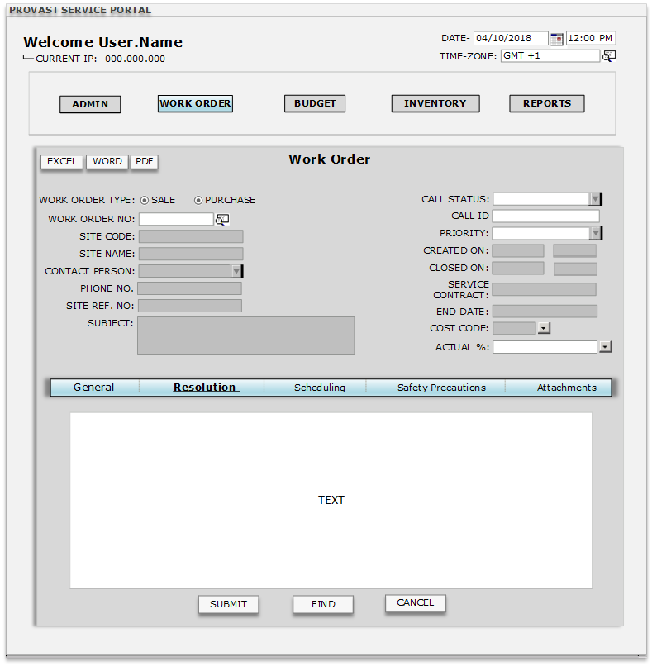

Work Order Type | This field will contain two options (Sale/Purchase) OSCL_BPType, which will be in the form of check box. The data entered in this field will be updated in SAP B1 database too. By default the (Sale) check box will be selected.  List will be filtered on the Basis of Work order type(If Check on Purchase then vendor list will be open and if sales is checked then Customer list will be open) here for purchase Cardtype is P and for sale cardtype is C
Work Order No. | This field will contain a W/O number which will be generated automatically according to the document numbering defined and this number will also update in SAP B1 database OSCL_DocNum screen.
Site Code | This field will contain the site code which will come from the W/O request added by the client on the portal. The data will also be updated on SAP B1 database (OSCL_CardCode) against the service call.
Site Name | This field will contain the info of site name which will come from the W/O request added by the client on the portal. The data will also be updated on SAP B1 database (OSCL_CardName).
Contact Person | This field will contain the name of the contact person linked with the particular site (linked in SAP B1 database) which is selected in the W/O request document. If no contact person is linked the field will be left blank. OSCL_ContactCode (coming with Customer/Supplier selection)
Phone No. | This field will contain the phone number linked with the particular site (linked in SAP B1 database) which is selected in the W/O request document. If no contact person is linked the field will be left blank. OSCL_Telephone (coming with Customer/Supplier selection Master table OCRD)
Site Ref No. | This field will contain the Site Reference Number linked with the particular site (linked in SAP B1 database) which is selected in the W/O request document. If no contact person is linked the field will be left blank. OSCL_NumAtCard (coming with Customer/Supplier selection Master table OCRD)
Subject | This field will contain the subject text which will come automatically from the W/O request document created by the client. This field will remain open for further updates. Any update done will also be updated in SAP B1 database. OSCL_Subject (It is manually entered)
Call Status | This field will contain a drop down button with values like (Open/Closed/Pending) and will have an option of adding new value. The entries or changes done in this field will also be updated in SAP B1 database. OSCL_Status (By default status will be OPEN)
Call ID | This field will contain a Call ID number which will be similar to the number series present in the SAP B1 database. OSCL_callID (Will be automatically increasing number series)
Priority | This field will contain a drop down button with values like (Low/Medium/High) The entries done in this field will also be updated in SAP B1 database. OSCL_priority (By default will be LOW)
Created On | This field will contain the date and time when the W/O request is added by the client. This field will remain freezed and data will be updated in SAP B1 database also. OSCL_createDate, OSCL_createTime (Will automatically pick from system’s date and time)
Closed On | This field will have the info of Date and Time when the W/O request is closed by the Super User. The data in field will be updated in SAP B1 database also. This field will remain freezed. OSCL_closeDate, OSCL_closeTime (Will automatically pick from system’s date and time)
Service Contract | This field will have the Service Contract Number which will come from the linked contact for a site in the SAP B1 database. This field will remain freezed. OSCL_contractID (Will come from the contract defined in item master data OITM)
End Date | This field will have the Service contract end date which will come from the linked contact for a site in the SAP B1 database. This field will remain freezed. OSCL_cntrctDate (The date will come from data specified in the service contract in OITM item master)
Cost Code | Cost Code field will contain a CFL button which will display the list of all Cost/Account codes for selection purpose, this will come from SAP Database. OOCR_OcrName.
Actual % | This field will contain a drop down button support user and facility coordinator will update according to their work in progress. Will come from (OSCL_U_ACT) SAP B1 database.
Text Box | This field will be a free text box that will allow the Facility coordinator/user to add info related to solution. The data entered in the box will also be updated in the SAP B1 database(OSCL_Resolution)
Submit | Clicking Submit Button will add the document in the system. After submitting the document this will update the work order screen(OSCL)
Find | Clicking the find button will auto-freeze the window except Site code. In site code the user will be able to find by inserting * (It will open a new window with all the site with their site, location, sub-location, sub-sub location and asset.) or selecting the particular site.
Cancel | Clicking Cancel Button will close the window.  (NOTE- While clicking on cancel button system will ask user to save the document, for saving the document system will ask YES or NO.)

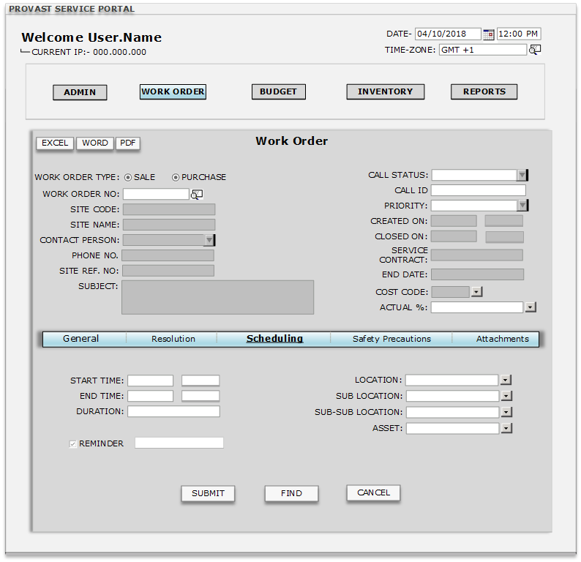

Work Order Type | This field will contain two options (Sale/Purchase) OSCL_BPType, which will be in the form of check box. The data entered in this field will be updated in SAP B1 database too. By default the (Sale) check box will be selected.  List will be filtered on the Basis of Work order type (If Check on Purchase then vendor list will be open and if sales is checked then Customer list will be open) here for purchase Cardtype is P and for sale cardtype is C
Work Order No. | This field will contain a W/O number which will be generated automatically according to the document numbering defined and this number will also update in SAP B1 database OSCL_DocNum screen.
Site Code | This field will contain the site code which will come from the W/O request added by the client on the portal. The data will also be updated on SAP B1 database (OSCL_CardCode) against the service call.
Site Name | This field will contain the info of site name which will come from the W/O request added by the client on the portal. The data will also be updated on SAP B1 database (OSCL_CardName).
Contact Person | This field will contain the name of the contact person linked with the particular site (linked in SAP B1 database) which is selected in the W/O request document. If no contact person is linked the field will be left blank. OSCL_ContactCode (coming with Customer/Supplier selection)
Phone No. | This field will contain the phone number linked with the particular site (linked in SAP B1 database) which is selected in the W/O request document. If no contact person is linked the field will be left blank. OSCL_Telephone (coming with Customer/Supplier selection Master table OCRD)
Site Ref No. | This field will contain the Site Reference Number linked with the particular site (linked in SAP B1 database) which is selected in the W/O request document. If no contact person is linked the field will be left blank. OSCL_NumAtCard (coming with Customer/Supplier selection Master table OCRD)
Subject | This field will contain the subject text which will come automatically from the W/O request document created by the client. This field will remain open for further updates. Any update done will also be updated in SAP B1 database. OSCL_Subject (It is manually entered)
Call Status | This field will contain a drop down button with values like (Open/Closed/Pending) and will have an option of adding new value. The entries or changes done in this field will also be updated in SAP B1 database. OSCL_Status (By default status will be OPEN)
Call ID | This field will contain a Call ID number which will be similar to the number series present in the SAP B1 database. OSCL_callID (Will be automatically increasing number series)
Priority | This field will contain a drop down button with values like (Low/Medium/High) The entries done in this field will also be updated in SAP B1 database. OSCL_priority (By default will be LOW)
Created On | This field will contain the date and time when the W/O request is added by the client. This field will remain freezed and data will be updated in SAP B1 database also. OSCL_createDate, OSCL_createTime (Will automatically pick from system’s date and time)
Closed On | This field will have the info of Date and Time when the W/O request is closed by the Super User. The data in field will be updated in SAP B1 database also. This field will remain freezed. OSCL_closeDate, OSCL_closeTime (Will automatically pick from system’s date and time)
Service Contract | This field will have the Service Contract Number which will come from the linked contact for a site in the SAP B1 database. This field will remain freezed. OSCL_contractID (Will come from the contract defined in item master data OITM)
End Date | This field will have the Service contract end date which will come from the linked contact for a site in the SAP B1 database. This field will remain freezed. OSCL_cntrctDate (The date will come from data specified in the service contract in OITM item master)
Cost Code | Cost Code field will contain a CFL button which will display the list of all Cost/Account codes for selection purpose, this will come from SAP Database. OOCR_OcrName.
Actual % | This field will contain a drop down button support user and facility coordinator will update according to their work in progress. Will come from (OSCL_U_ACT) SAP B1 database.
Start Time | This field will contain the Date and Time when the work on a W/O request has started. By default the field will have system default date and time. The data in field will be updated in SAP B1 database also. OSCL_StartDate, OSCL_StartTime (Will come from the system date and time)
End Time | This field will contain the Date and Time when the work on a W/O request has to be completed. By default the field will have system default date and time with (15 minutes) added to it. The data in field will be updated in SAP B1 database also. OSCL_EndDate, OSCL_EndTime. (Will come from the system date and time)
Duration | This field will automatically calculate the total duration of a work order from Start Time and End Time field in format as  (x Days, x Hours, x Minutes). By default the value will be 15 minutes. The data in field will be updated in SAP B1 database also. OSCL_Duration
Reminder | This field will contain a check box which will help in enabling this feature. The field will allow super user to set a reminder on the status of work order in the format(x Days, x Hours, x Minutes).  By default the check box will remain unticked. OSCL_Reminder, OSCL_RemQty
Location | This field will have the info of the Site’s location. This info will come automatically from the W/O request added by the client. (OSCL,U_LOC)
Sub Location | This field will have the info of the Site’s Sub location. This info will come automatically from the W/O request added by the client. (OSCL,U_SLOC)
Sub-Sub Location | This field will have the info of the Site’s Sub-Sub location. This info will come automatically from the W/O request added by the client. (OSCL,U_SSLOCATION)
Asset | This field will have the info of the Asset present on the Site. This info will come automatically from the W/O request added by the client. (OSCL,U_Asset)
Submit | Clicking Submit Button will add the document in the system. (OSCL)
Find | Clicking the find button will auto-freeze the window except Site code. In site code the user will be able to find by inserting * (It will open a new window with all the site with their site, location, sub-location, sub-sub location and asset.) or selecting the particular site.
Cancel | Clicking Cancel Button will close the window.  (NOTE- While clicking on cancel button system will ask user to save the document, for saving the document system will ask YES or NO.)

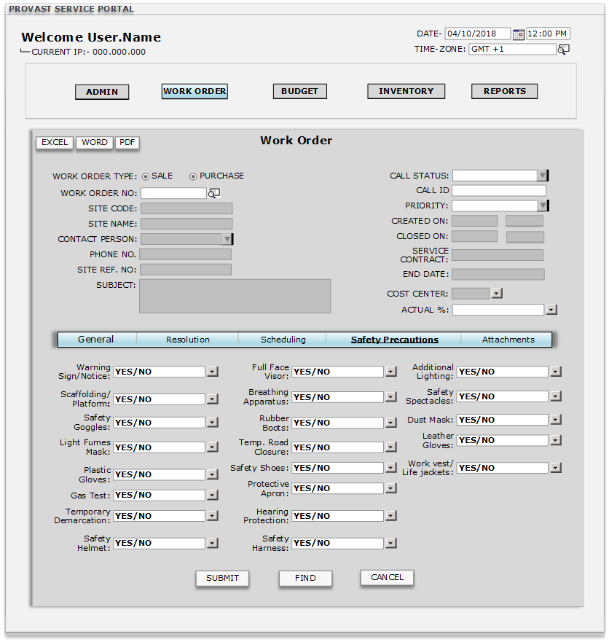
Work Order Type | This field will contain two options (Sale/Purchase) OSCL_BPType, which will be in the form of check box. The data entered in this field will be updated in SAP B1 database too. By default the (Sale) check box will be selected.  List will be filtered on the Basis of Work order type(If Check on Purchase then vendor list will be open and if sales is checked then Customer list will be open) here for purchase Cardtype is P and for sale cardtype is C
Work Order No. | This field will contain a W/O number which will be generated automatically according to the document numbering defined and this number will also update in SAP B1 database OSCL_DocNum screen.
Site Code | This field will contain the site code which will come from the W/O request added by the client on the portal. The data will also be updated on SAP B1 database (OSCL_CardCode) against the service call.
Site Name | This field will contain the info of site name which will come from the W/O request added by the client on the portal. The data will also be updated on SAP B1 database (OSCL_CardName).
Contact Person | This field will contain the name of the contact person linked with the particular site (linked in SAP B1 database) which is selected in the W/O request document. If no contact person is linked the field will be left blank. OSCL_ContactCode (coming with Customer/Supplier selection)
Phone No. | This field will contain the phone number linked with the particular site (linked in SAP B1 database) which is selected in the W/O request document. If no contact person is linked the field will be left blank. OSCL_Telephone (coming with Customer/Supplier selection Master table OCRD)
Site Ref No. | This field will contain the Site Reference Number linked with the particular site (linked in SAP B1 database) which is selected in the W/O request document. If no contact person is linked the field will be left blank. OSCL_NumAtCard (coming with Customer/Supplier selection Master table OCRD)
Subject | This field will contain the subject text which will come automatically from the W/O request document created by the client. This field will remain open for further updates. Any update done will also be updated in SAP B1 database. OSCL_Subject (It is manually entered)
Call Status | This field will contain a drop down button with values like (Open/Closed/Pending) and will have an option of adding new value. The entries or changes done in this field will also be updated in SAP B1 database. OSCL_Status (By default status will be OPEN)
Call ID | This field will contain a Call ID number which will be similar to the number series present in the SAP B1 database. OSCL_callID (Will be automatically increasing number series)
Priority | This field will contain a drop down button with values like (Low/Medium/High) The entries done in this field will also be updated in SAP B1 database. OSCL_priority (By default will be LOW)
Created On | This field will contain the date and time when the W/O request is added by the client. This field will remain freezed and data will be updated in SAP B1 database also. OSCL_createDate, OSCL_createTime (Will automatically pick from system’s date and time)
Closed On | This field will have the info of Date and Time when the W/O request is closed by the Super User. The data in field will be updated in SAP B1 database also. This field will remain freezed. OSCL_closeDate, OSCL_closeTime (Will automatically pick from system’s date and time)
Service Contract | This field will have the Service Contract Number which will come from the linked contact for a site in the SAP B1 database. This field will remain freezed. OSCL_contractID (Will come from the contract defined in item master data OITM)
End Date | This field will have the Service contract end date which will come from the linked contact for a site in the SAP B1 database. This field will remain freezed. OSCL_cntrctDate (The date will come from data specified in the service contract in OITM item master)
Cost Code | Cost Code field will contain a CFL button which will display the list of all Cost/Account codes for selection purpose, this will come from SAP Database. OOCR_OcrName.
Actual % | This field will contain a drop down button support user and facility coordinator will update according to their work in progress. Will come from (OSCL_U_ACT) SAP B1 database.
Warning Sign/Notice | This field will have a drop down button with two values (YES/NO) and the default value will be NO. The value updated in this field will also be updated in SAP B1 database. (OSCL,U_Warng_Sgn)
Scaffolding Platform | This field will have a drop down button with two values (YES/NO) and the default value will be NO. The value updated in this field will also be updated in SAP B1 database. (OSCL,U_Scaff)
Safety Goggles | This field will have a drop down button with two values (YES/NO) and the default value will be NO. The value updated in this field will also be updated in SAP B1 database. (OSCL,U_SG)
Light Fumes Mask | This field will have a drop down button with two values (YES/NO) and the default value will be NO. The value updated in this field will also be updated in SAP B1 database. (OSCL,U_LFM)
Plastic Gloves | This field will have a drop down button with two values (YES/NO) and the default value will be NO. The value updated in this field will also be updated in SAP B1 database. (OSCL,U_PG)
Gas Test | This field will have a drop down button with two values (YES/NO) and the default value will be NO. The value updated in this field will also be updated in SAP B1 database. (OSCL,U_GT)
Temporary Demarcation | This field will have a drop down button with two values (YES/NO) and the default value will be NO. The value updated in this field will also be updated in SAP B1 database. (OSCL,U_TD)
Safety Helmet | This field will have a drop down button with two values (YES/NO) and the default value will be NO. The value updated in this field will also be updated in SAP B1 database. (OSCL,U_SH)
Full Face Visor | This field will have a drop down button with two values (YES/NO) and the default value will be NO. The value updated in this field will also be updated in SAP B1 database. (OSCL,U_FFV)
Breathing Apparatus | This field will have a drop down button with two values (YES/NO) and the default value will be NO. The value updated in this field will also be updated in SAP B1 database. (OSCL,U_BA)
Rubber Boots | This field will have a drop down button with two values (YES/NO) and the default value will be NO. The value updated in this field will also be updated in SAP B1 database. (OSCL,U_RB)
Temp. Road Closure | This field will have a drop down button with two values (YES/NO) and the default value will be NO. The value updated in this field will also be updated in SAP B1 database. (OSCL,U_TRC)
Safety Shoes | This field will have a drop down button with two values (YES/NO) and the default value will be NO.  The value updated in this field will also be updated in SAP B1 database. (OSCL,U_SS)
Protective Apron | This field will have a drop down button with two values (YES/NO) and the default value will be NO. The value updated in this field will also be updated in SAP B1 database. (OSCL,U_PA)
Hearing Protection | This field will have a drop down button with two values (YES/NO) and the default value will be NO. The value updated in this field will also be updated in SAP B1 database. (OSCL,U_HP)
Safety Harness | This field will have a drop down button with two values (YES/NO) and the default value will be NO. The value updated in this field will also be updated in SAP B1 database. (OSCL,U_SHA)
Additional Lighting | This field will have a drop down button with two values (YES/NO) and the default value will be NO. The value updated in this field will also be updated in SAP B1 database. (OSCL,U_AL)
Safety Spectacles | This field will have a drop down button with two values (YES/NO) and the default value will be NO. The value updated in this field will also be updated in SAP B1 database. (OSCL,U_SSP)
Dust Mask | This field will have a drop down button with two values (YES/NO) and the default value will be NO. The value updated in this field will also be updated in SAP B1 database. (OSCL,U_DM)
Leather Gloves | This field will have a drop down button with two values (YES/NO) and the default value will be NO. The value updated in this field will also be updated in SAP B1 database. (OSCL,U_LG)
Work vest/Life Jackets | This field will have a drop down button with two values (YES/NO) and the default value will be NO. The value updated in this field will also be updated in SAP B1 database. (OSCL,U_WV)
Find | Clicking the find button will auto-freeze the window except Site code. In site code the user will be able to find by inserting * (It will open a new window with all the site with their site, location, sub-location, sub-sub location and asset.) or selecting the particular site.
Submit | Clicking Submit Button will add the document in the system. (OSCL)
Cancel | Clicking Cancel Button will close the window.  (NOTE- While clicking on cancel button system will ask user to save the document, for saving the document system will ask YES or NO.)

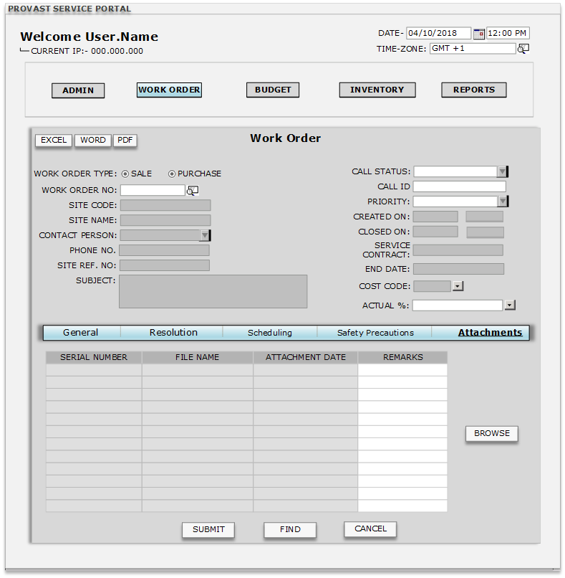
Work Order Type | This field will contain two options (Sale/Purchase) OSCL_BPType, which will be in the form of check box. The data entered in this field will be updated in SAP B1 database too. By default the (Sale) check box will be selected.  List will be filtered on the Basis of Work order type(If Check on Purchase then vendor list will be open and if sales is checked then Customer list will be open) here for purchase Cardtype is P and for sale cardtype is C
Work Order No. | This field will contain a W/O number which will be generated automatically according to the document numbering defined and this number will also update in SAP B1 database OSCL_DocNum screen.
Site Code | This field will contain the site code which will come from the W/O request added by the client on the portal. The data will also be updated on SAP B1 database (OSCL_CardCode) against the service call.
Site Name | This field will contain the info of site name which will come from the W/O request added by the client on the portal. The data will also be updated on SAP B1 database (OSCL_CardName).
Contact Person | This field will contain the name of the contact person linked with the particular site (linked in SAP B1 database) which is selected in the W/O request document. If no contact person is linked the field will be left blank. OSCL_ContactCode (coming with Customer/Supplier selection)
Phone No. | This field will contain the phone number linked with the particular site (linked in SAP B1 database) which is selected in the W/O request document. If no contact person is linked the field will be left blank. OSCL_Telephone (coming with Customer/Supplier selection Master table OCRD)
Site Ref No. | This field will contain the Site Reference Number linked with the particular site (linked in SAP B1 database) which is selected in the W/O request document. If no contact person is linked the field will be left blank. OSCL_NumAtCard (coming with Customer/Supplier selection Master table OCRD)
Subject | This field will contain the subject text which will come automatically from the W/O request document created by the client. This field will remain open for further updates. Any update done will also be updated in SAP B1 database. OSCL_Subject (It is manually entered)
Call Status | This field will contain a drop down button with values like (Open/Closed/Pending) and will have an option of adding new value. The entries or changes done in this field will also be updated in SAP B1 database. OSCL_Status (By default status will be OPEN)
Call ID | This field will contain a Call ID number which will be similar to the number series present in the SAP B1 database. OSCL_callID (Will be automatically increasing number series)
Priority | This field will contain a drop down button with values like (Low/Medium/High) The entries done in this field will also be updated in SAP B1 database. OSCL_priority (By default will be LOW)
Created On | This field will contain the date and time when the W/O request is added by the client. This field will remain freezed and data will be updated in SAP B1 database also. OSCL_createDate, OSCL_createTime (Will automatically pick from system’s date and time)
Closed On | This field will have the info of Date and Time when the W/O request is closed by the Super User. The data in field will be updated in SAP B1 database also. This field will remain freezed. OSCL_closeDate, OSCL_closeTime (Will automatically pick from system’s date and time)
Service Contract | This field will have the Service Contract Number which will come from the linked contact for a site in the SAP B1 database. This field will remain freezed. OSCL_contractID (Will come from the contract defined in item master data OITM)
End Date | This field will have the Service contract end date which will come from the linked contact for a site in the SAP B1 database. This field will remain freezed. OSCL_cntrctDate (The date will come from data specified in the service contract in OITM item master)
Cost Code | Cost Code field will contain a CFL button which will display the list of all Cost/Account codes for selection purpose, this will come from SAP Database. OOCR_OcrName.
Actual % | This field will contain a drop down button support user and facility coordinator will update according to their work in progress. Will come from (OSCL_U_ACT) SAP B1 database.
Serial Number | This field will be read-only and will automatically retain numbering series according to the number of attachments added.
File name | This field will be read-only and will capture the name of the file that is being attached to the Work-Order.  (NOTE- File would be in Word/PDF/JPEG/EXCEL format)
Attachment date | This field will be read-only and will automatically pick the date from the system’s date when a document is attached for a work order.
Remarks | This field will be free text field for remarks entry related with different attached documents.
Browse | Clicking Browse button will open a window that will allow the user to find and select the specific find that has to be attached with a particular work order.
Find | Clicking the find button will auto-freeze the window except Site code. In site code the user will be able to find by inserting * (It will open a new window with all the site with their site, location, sub-location, sub-sub location and asset.) or selecting the particular site.
Submit | Clicking Submit Button will add the document in the system. After submitting the document this will update the work order screen(OSCL)
Cancel | Clicking Cancel Button will close the window.  (NOTE- While clicking on cancel button system will ask user to save the document, for saving the document system will ask YES or NO.)

Budget Setup
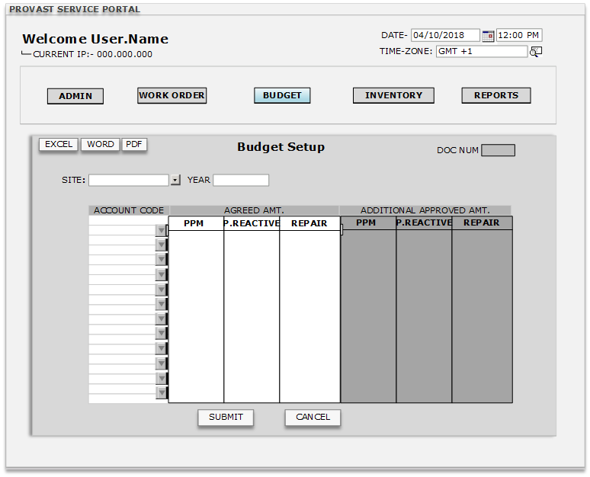
Doc Num | Doc Num field will have an auto generated document number for every document added in the window.
Site | This is for selection of Site/client, CFL will be there, and data will come from OCRD_BpName from Sap database. Site will be only in selection mode when user type is client user.
Year | This field will allow user to select the year for which the budget setup has to be done for the particular client.
Account Code | These fields will contain a CFL button which will open a list containing all account codes added in the SAP database system. OOCR_OcrCode
Agreed AMT (PPM, P_Reactive, Repair) | This field will be a free text field which will allow user to enter the agreed budget as numeric value.  (NOTE- The user will input the numeric value of the budget in any of these 3 options and that will reflect everywhere in the system.)
Additional Approved AMT  (PPM, P_Reactive, Repair) | This field will be freezed and will contain the additional approved amount value which will come from client’s approval document. (NOTE- This data will come from excess approval budget, there also user will input the value the account code in any of these three column.)
Submit | Clicking Submit Button will add the document in the system.
Cancel | Clicking Cancel Button will close the window.  (NOTE- While clicking on cancel button system will ask user to save the document, for saving the document system will ask YES or NO.)
Validation
1. | In agreed tab (PPM, P Reactive and Repair will come from OSCL_ProSubTyp)
2. | PPM, P Reactive and Repair will be linked with OSCL_ProSubType. Whatever the field is here and the account selected here will be used in calculating the different work orders with respect to different sales order cost.

Excess Budget Approval

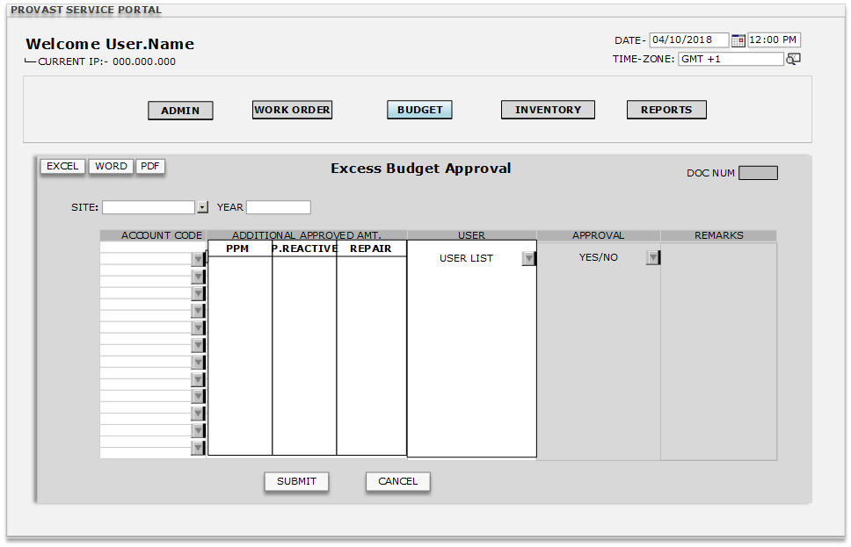
Doc Num | Doc Num field will have an auto generated document number for every document added in the window.
Site | This is for selection of Site/client, CFL will be there, and data will come from OCRD_BpName from Sap database. Site will be only in selection mode when user type is client user.
Year | This field will allow user to select the year for which the budget setup has to be done for the particular client.
Account Code | These fields will contain a CFL button which will open a list containing all account codes added in the SAP database system. OOCR_OcrCode
Additional Approved Amt.  (PPM, P_Reactive, Repair) | This field will be a free numeric field which will allow the user to enter the additional amount for a site.  (NOTE- Once the user will input the amount that will be only reflect after the approval of this amount by the concerned user for a particular site.)
User | User list will be filtered by site, user list will come from user master setup for the site.  (NOTE- The user which will be selected here will receive Email with a link, after clicking the link user will open the screen all the column will be freezed except for the Approval tab with value YES/NO.)  (NOTE2- If YES then this amount will be added to the budget setup screen (In additional approved amount) if NO then this row will be Red colured and will not effect anywhere.)
Approval | This field will contain a drop-down button with values YES and NO. Once user will click on the link this column will be editable, he can select YES/NO. If YES is selected by site user then this additional amount will be added to the Budget setup’s additional amount column.
Remarks | This is free text field only for the site users.  After approval YES remarks will be automatically show Approved and for NO it will show Denied
Submit | Clicking Submit Button will add the document in the Portal and will send an Email to the selected user in that row with a link of Budget approval.
Cancel | Clicking Cancel Button will close the window.  (NOTE- While clicking on cancel button system will ask user to save the document, for saving the document system will ask YES or NO.)
Validation
1. | If user will reject the approved amount then that field will be editable, if the amount is changed then again the site user will receive Email to approve or reject.

Budget Expense Report

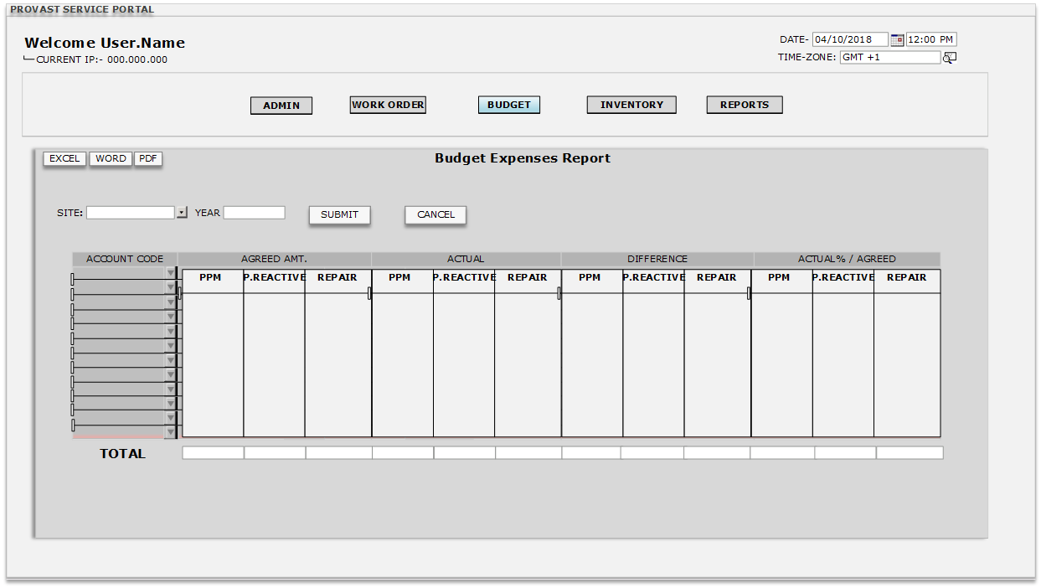

Site | This is for selection of Site/client, CFL will be there, and data will come from OCRD_BpName from Sap database. Site will be only in selection mode when user type is client user.
Year | This field will allow user to select the year for which the budget setup has to be done for the particular client.
Submit | Clicking Submit Button will provide the result according to Site and the selected year. (NOTE- If the site user will open this report then site will be automatically selected)
Cancel | Clicking Cancel Button will close the window.  (NOTE- While clicking on cancel button system will ask user to save the document, for saving the document system will ask YES or NO.)
Account Code | These fields will contain a CFL button which will open a list containing all account codes added in the SAP database system. OOCR_OcrCode
Agreed AMT  (PPM, P_Reactive, Repair) | These fields will be freezed and will show the Agreed Amount which is initialized in the budget setup for a particular site and year.
Actual  (PPM, P_Reactive, Repair) | These fields will be freezed and will contain the value of total actual value from budget setup for that particular site and year.
Difference  (PPM, P_Reactive, Repair) | These fields will be freezed and will contain the value of exceeded amount for a particular site.  (NOTE- Exceeded AMT = Agreed AMT – Actual)
Actual% / Agreed | The actual percentage which has been increased or decreased from the agreed amount will come here by calculation of agreed and actual column.  (NOTE- Difference will be in percentage value)
Total | Column wise total will be there for total values of different columns.
Validation
1 | After logging, client will be able to see their data only

Material Requisition
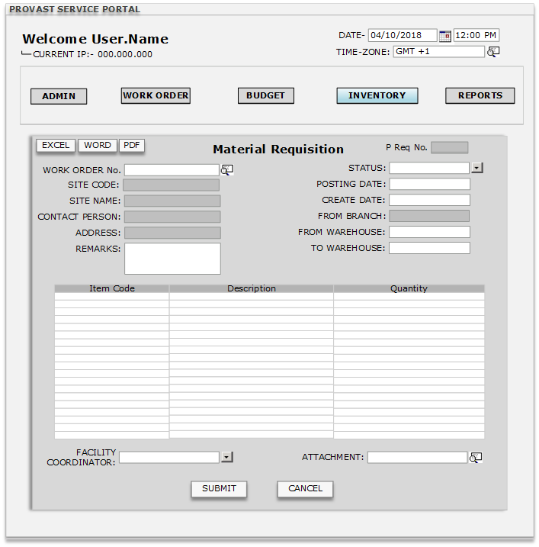

P Req No. | P requisition number field will have an auto generated document number for every site added in the window.
Work Order No. | This field will contain a W/O number which will be generated automatically according to the document numbering defined and this number will also update in SAP B1 database OSCL_DocNum screen.
Site Code | There will be a CFL to select the site (OWTQ_CardCode) from SAP database.
Site Name | Site Name will come automatically from (OWTQ_CardName) SAP database when Site code is selected.
Contact Person | Contact person’s name will come automatically from (OCPR_Name) when site code is selected.  (NOTE- The contact person linked with this BP will be updated here.)
Address | Address name will come automatically from (OWTQ_Address) when site code is selected.
Remarks | Remark field will be free text field for entering remarks. (OWTQ_comments)
Status | This field will show the status of the material requisition window. (OWTQ_DocStatus)
Posting Date | The posting date of the document will be the current system date. (OWTQ_DocDate)
Doc Date | Doc Date field will be the document date that will come automatically from the system’s date. (It will be editable) (OWTQ_TaxDate)
From Branch | This field will remain freezed. Default branch will appear here which is defined in SAP. (OWTQ_BPLid)
From Warehouse | Default warehouse name will be selected automatically for the item defined in item master (OITM) (OITW_WhsCode) and also update in SAP database OWTR_Filler.
To Warehouse | Default warehouse name SERVICE (OWHS_WhsName) will be here and also update in SAP database. (OWTQ_ToWhsCode)
Item Code | Item Code fields will contain a CFL button which is linked with (OITM_ItemCode, OITM_ItemName) from Item_Master of SAP B1 database.  This will update in WTQ1_ItemCode in SAP B1 database.  (NOTE- This process will be vice versa with description. Search button will be present to search data by Name and Letters.)
Description | Item Code fields will contain a CFL button which is linked with (OITM_Dscription, OITM_ItemCode) from Item_Master of SAP B1 database.  This will update in WTQ1_Dscription in SAP B1 database.  (NOTE- This process will be vice versa with description. Search button will be present to search data by Name and Letters.)
Quantity | Quantity fields will be free text space containing info of the requested quantity of the specific item.  This quantity will update WTQ1_quantity in SAP B1 database.  (NOTE- Will contain only numeric values.)
Facility Coordinator | This field will have a CFL which will be linked with OHEM_EmployeeMaster. This will also update in OWTR_SlpCode  NOTE- This data (OHEM_EmpID, OHEM_FirstName, OHEM_LastName, and OHEM_Dept) will be in column form in the list so that user can choose anyone from the list.
Attachment | Here the user will attach any Document (PDF, JPEG, WORD, EXCEL) this will update in ATC1_TrgtPath
Submit | After clicking on submit button this all data will be updated in SAP OWTQ (Inventory transfer request form) and also this document will be added in the portal.  (NOTE- Also gives alert to the specific user through internal alert and Emails.)
Cancel | Clicking Cancel Button will close the window.  (NOTE- While clicking on cancel button system will ask user to save the document, for saving the document system will ask YES or NO.)

Material Transfer
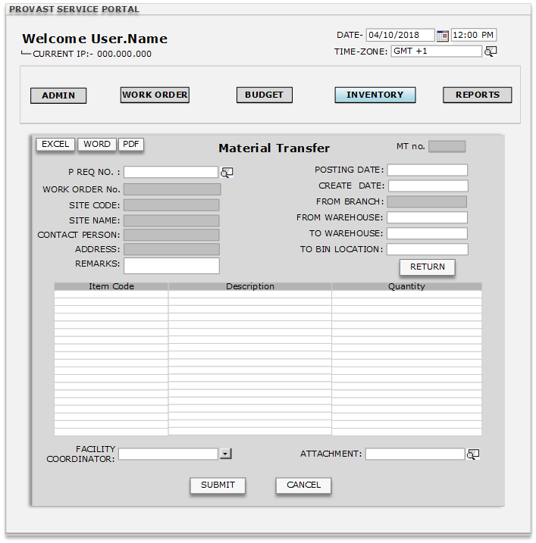

MT NO. | Material transfer number field will have an auto generated document number for every site added in the window.  (NOTE- This field will be updated after adding the document in SAP B1 database (OWTR screen table)
P Req No. | The number in this field will come from OWTQ (Linked inventory request number- OWTQ_DocNum.  (NOTE- This will automatically update here after creating in SAP database)  (NOTE2- Whenever new material transfer will be added in the SAP B1 database here on portal a new material transfer will be added.  (NOTE- Also gives alert to the specific user through internal alert and Emails.)  (NOTE- This field will be updated after adding the document in SAP B1 database (OWTR screen table)
Work Order No. | This field will contain a W/O number which will be generated automatically according to the document numbering defined and this number will also update in SAP B1 database OSCL_DocNum screen.
Site code | There will be a CFL to select the site (OWTR_CardCode) from SAP database.  (NOTE- This field will be updated after adding the document in SAP B1 database (OWTR screen table)
Site Name | Site Name will come automatically from (OWTR_CardName) SAP database when Site code is selected.  (NOTE- This field will be updated after adding the document in SAP B1 database (OWTR screen table)
Contact Person | Contact person’s name will come automatically from (OCPR_Name) when site code is selected.  (NOTE- The contact person linked with this BP will be updated here.)  (NOTE- This field will be updated after adding the document in SAP B1 database (OWTR screen table)
Address | Address name will come automatically from (OWTR_Address) when site code is selected.  (NOTE- This field will be updated after adding the document in SAP B1 database (OWTR screen table)
Remarks | Remark field will be free text field for entering remarks. (OWTR_comments)  (NOTE- This field will be updated after adding the document in SAP B1 database (OWTR screen table)
Posting Date | The posting date of the document will be the current system date. (OWTR_DocDate)  (NOTE- This field will be updated after adding the document in SAP B1 database (OWTR screen table)
Doc Date | Doc Date field will be the document date that will come automatically from the system’s date. (It will be editable) (OWTR_TaxDate)  (NOTE- This field will be updated after adding the document in SAP B1 database (OWTR screen table)
From Branch | This field will remain freezed. Default branch will appear here which is defined in SAP. (OWTR_BPLid)  (NOTE- This field will be updated after adding the document in SAP B1 database (OWTR screen table)
From Warehouse | Default warehouse name will be selected automatically for the item defined in item master (OITM) (OITW_WhsCode) and also update in SAP database OWTR_Filler.  (NOTE- This field will be updated after adding the document in SAP B1 database (OWTR screen table)
To Warehouse | Default warehouse name SERVICE (OWHS_WhsName) will be here and also update in SAP database. (OWTR_ToWhsCode)  (NOTE- This field will be updated after adding the document in SAP B1 database (OWTR screen table)
To Bin Location | It will come from SAP database (OWTR_ToBinCode)  (NOTE- This field will be updated after adding the document in SAP B1 database (OWTR screen table)
Item Code | Item Code fields will contain a CFL button which is linked with (OITM_ItemCode, OITM_ItemName) from Item_Master of SAP B1 database.  This will update in WTQ1_ItemCode in SAP B1 database.  (NOTE- This process will be vice versa with description. Search button will be present to search data by Name and Letters.)  (NOTE- This field will be updated after adding the document in SAP B1 database (OWTR screen table)
Description | Item Code fields will contain a CFL button which is linked with (OITM_Dscription, OITM_ItemCode) from Item_Master of SAP B1 database.  This will update in WTQ1_Dscription in SAP B1 database.  (NOTE- This process will be vice versa with description. Search button will be present to search data by Name and Letters.)  (NOTE- This field will be updated after adding the document in SAP B1 database (OWTR screen table)
Quantity | Quantity fields will be free text space containing info of the requested quantity of the specific item.  This quantity will update WTQ1_quantity in SAP B1 database.  (NOTE- Will contain only numeric values.)  (NOTE- This field will be updated after adding the document in SAP B1 database (OWTR screen table)
Facility Coordinator | This field will have a CFL which will be linked with OHEM_EmployeeMaster. This will also update in OWTR_SlpCode  NOTE- This data (OHEM_EmpID, OHEM_FirstName, OHEM_LastName, and OHEM_Dept) will be in column form in the list so that user can choose anyone from the list.  (NOTE- This field will be updated after adding the document in SAP B1 database (OWTR screen table)
Attachment | Here the user will attach any Document (PDF, JPEG, WORD, EXCEL) this will update in ATC1_TrgtPath  (NOTE- This field will be updated after adding the document in SAP B1 database (OWTR screen table)
Return | This button is only enabled on Material Transfer document to return the quantity. After clicking on this button a new window will open named as Material Return. This return will be enable only for the receipt Item  (NOTE- In that form only quantity field will be enabled, posting date and document date will current system date)
Submit | After clicking on submit button this all data will be updated in SAP OWTR (Inventory transfer form) and also this document will be added in the portal.  (NOTE- Also gives alert to the specific user through internal alert and Emails.)
Cancel | Clicking Cancel Button will close the window.  (NOTE- While clicking on cancel button system will ask user to save the document, for saving the document system will ask YES or NO.)
Validation

1 | Item should be 100% same it can be less but not more,also the quantity will be same or less not greater than the Request qty.

- Material Return
This screen will open if the Facility Coordinator/User has completed his job and the quantity of items are left with him then the Facility coordinator/User will click on return button on the Material Transfer screen (Material Transfer Number will be selected for which return is to be done.)
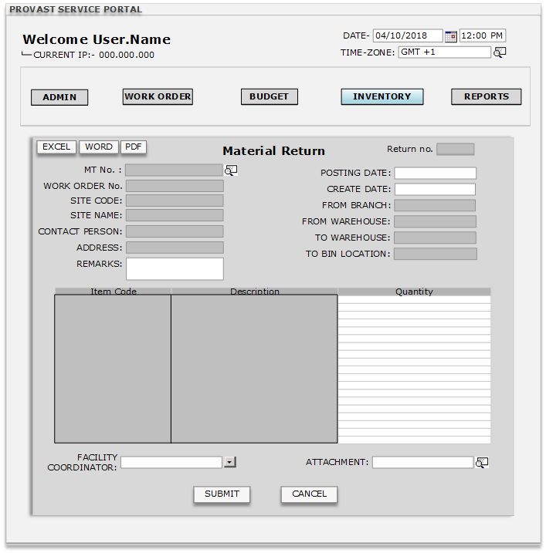
Return No. | Return number field will have an auto generated document number for every site added in the window.  (NOTE- This field will be updated after adding the document in SAP B1 database (OWTR screen table)  (NOTE- New inventory transfer document will be added in the SAP B1 database.)
MT No. | This field will contain a CFL which allow the user to choose the Material Transfer number which has been received by the facility transfer coordinator from the store.  (NOTE- In the CFL only that material transfer number will appear for which there is no material return is created.)
Work Order No. | This field will contain a W/O number which will be generated automatically according to the document numbering defined and this number will also update in SAP B1 database OSCL_DocNum screen.
Site code | This field will remain freezed and will retain value from selected Material transfer document.
Site Name | This field will remain freezed and will retain value from selected Material transfer document.
Contact Person | This field will remain freezed and will retain value from selected Material transfer document.
Address | This field will remain freezed and will retain value from selected Material transfer document.
Remarks | Remark field will be free text field for entering remarks. (OWTR_comments)
Posting Date | The posting date of the document will be the current system date. (OWTR_DocDate)
Doc Date | Doc Date field will be the document date that will come automatically from the system’s date. (It will be editable) (OWTR_TaxDate)
From Branch | This field will remain freezed and will retain value from selected Material transfer document.
From Warehouse | This field will remain freezed and the value of this field will come from (To Warehouse) field of the Material Transfer window.
To Warehouse | This field will remain freezed and the value of this field will come from (From Warehouse) field of the Material Transfer window.
To Bin Location | This field will remain freezed and will retain value from selected Material transfer document. It will come from SAP database
Item Code | This field will remain freezed and will retain value from selected Material transfer document.
Description | This field will remain freezed and will retain value from selected Material transfer document.
Quantity | Quantity fields will be free text space containing info of the returning quantity of the specific item.  (NOTE- The quantity mentioned in this field will be added back to the warehouse from where the Material transfer was earlier done.)  (NOTE- Will contain only numeric values.)
Facility Coordinator | This field will have a CFL which will be linked with OHEM_EmployeeMaster. This will also update in OWTR_SlpCode  (NOTE- This data (OHEM_EmpID, OHEM_FirstName, OHEM_LastName, and OHEM_Dept) will be in column form in the list so that user can choose anyone from the list.)
Attachment | Here the user will attach any Document (PDF, JPEG, WORD, EXCEL) this will update in ATC1_TrgtPath
Submit | After clicking on the submit button the data in the window will be added in the portal as well SAP B1 database OWTR inventory transfer screen. (New inventory transfer will be added in SAP)  (NOTE- Also gives alert to the specific user through internal alert and Emails.)
Cancel | Clicking Cancel Button will close the window.  (NOTE- While clicking on cancel button system will ask user to save the document, for saving the document system will ask YES or NO.)
Validation
1 | Return quantity should be equal or less then the receipt qty.

Reports

  - Work order Status Report (Open/Close/Canceled)
  - Work order client wise (Location /Sub location /Sub-Sub location/asset)
  - Work order Report (weekly/monthly/quarterly/yearly)
  - Monitor-Location wise/Filter (PPM/Including PPM/Excluding PPM)
  - Budget Client wise
  - Budget Location wise
  - Budget Asset wise

Company Logo Attachment- (For developer’s reference)



